KJSCE/IT/SYBTech/SEM IV/AA/2020-21


Experiment No. : 4

Title: Implement Huffman Algorithm using Greedy approach

(Autonomous College Affiliated to University of Mumbai)
KJSCE/IT/SYBTech/SEM IV/AA/2020-21

Batch:B2 Roll No.:1914078 Experiment No.:4

Aim: Implement Huffman Algorithm using Greedy approach and analyse its time complexity.

Algorithm:


- Input:-String to be coded
- Process string and calculate frequency of unique characters
- Output: - Huffman merge tree.
- Begin
- Let PQ be the priority queue,
- PQ= {initialize priority queue with frequencies of all symbol or message}
- Repeat n-1 times
- Create a new node C
- X=extract_min(PQ)
- Y=extract_min(PQ)
- Frequency(C) =Frequency(X) +Frequency(y);
- Insert (C, PQ)
- End repeat
- Return (extract_min(PQ))
- End.

Example of Variable Huffman Code with Step by Step Execution

Symbols | Frequency
A | 30
B | 30
C | 15
D | 15
E | 10

Pick last 2 nodes, delete them.
Create new node adding these 2 and their frequencies and add it to the list.
Sort the list.
Symbols | Frequency
A | 30
B | 30
DE | 25
C | 15

Again pick the last 2 nodes C and DE and add them. Delete C and DE and add the new node and sort it again.
DEC | 40
A | 30
B | 30
Repeat the process until there is only one node.
AB | 60
DEC | 40

ABDEC | 100

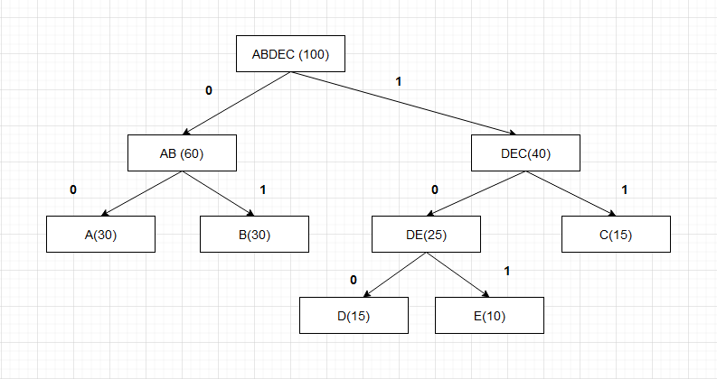

Symbols | Frequency | Codeword
A | 30 | 00
B | 30 | 01
C | 15 | 11
D | 15 | 100
E | 10 | 101

Derivation of Analysis:

Time complexity.
O(nlogn) where n is the number of unique characters. If there are n nodes, extractMin() is called 2*(n – 1) times. extractMin() takes O(logn) time as it calles minHeapify(). So, overall complexity is O(nlogn).

Program(s):

import java.util.*;
import java.io.*;

// node
class NodeHuffmann {

int data;
char c;

NodeHuffmann left;
NodeHuffmann right;
}

class compareData implements Comparator<NodeHuffmann> {
public int compare(NodeHuffmann x, NodeHuffmann y) {

return x.data - y.data;
}
}

class Huffman {

// recursive function to print the huffmann code
public static void printCodedHuffman(NodeHuffmann root, String s) {

// base case - leaf node
if (root.left == null && root.right == null && Character.isLetter(root.c)) {
System.out.println(root.c + ":" + s);
return;
}

printCodedHuffman(root.left, s + "0");
printCodedHuffman(root.right, s + "1");
}

public static void main(String[] args) {

Scanner s = new Scanner(System.in);

System.out.println("Enter number of characters : ");
int n = s.nextInt();

char[] charArray = new char[n];
int[] charfreq = new int[n];

PriorityQueue<NodeHuffmann> q = new PriorityQueue<NodeHuffmann>(n, new compareData());

for (int i = 0; i < n; i++) {

// input
System.out.print("Enter character : ");
charArray[i] = s.next().charAt(0);
System.out.print("Enter frequency : ");
charfreq[i] = s.nextInt();

NodeHuffmann node = new NodeHuffmann();
node.c = charArray[i];
node.data = charfreq[i];
node.left = null;
node.right = null;
q.add(node);
}

NodeHuffmann root = null;
while (q.size() > 1) {

NodeHuffmann x = q.peek();
q.poll();

NodeHuffmann y = q.peek();
q.poll();

NodeHuffmann f = new NodeHuffmann();
f.data = x.data + y.data;
f.c = '-';
f.left = x;
f.right = y;
root = f;

q.add(f);
}

printCodedHuffman(root, "");
}
}

Output(o):

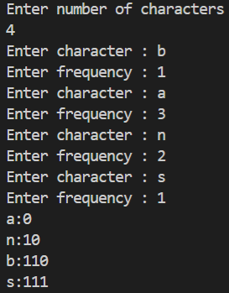

Questions:- Differentiate between Fixed length and Variable length Coding with suitable example.
Fixed Length:-

1. Every record in the file has exactly same size (in byte)
2. It take huge memory.
3. Access become fast.
4. Computer knows exact location of records so easy access.
5. Slow in transferring the records it has large size.
Variable length:-

1. Different record in the file have different size.
2. It take least memory.
3. Access become slow.
4. Computer does not know exact location of record so slow access.
5. Fast transferring as it is small in size

Outcome:

Implement Greedy and Dynamic Programming Algorithms

Conclusion: (Based on the observations):
We have learned how to implement Huffman algorithm using Greedy approach and analyze its complexity.

References:

- Richard E. Neapolitan, " Foundation of Algorithms ", 5th Edition 2016, Jones & Bartlett Students Edition

- Harsh Bhasin , " Algorithms : Design & Analysis", 1st Edition 2013, Oxford Higher education, India

- T.H. Coreman ,C.E. Leiserson,R.L. Rivest, and C. Stein, " Introduction to algorithms", 3rd Edition 2009, Prentice Hall India Publication

(Autonomous College Affiliated to University of Mumbai)

